Step to add a Line and coverage match before payment:
1. Click add line in quick launch menu in the claimant
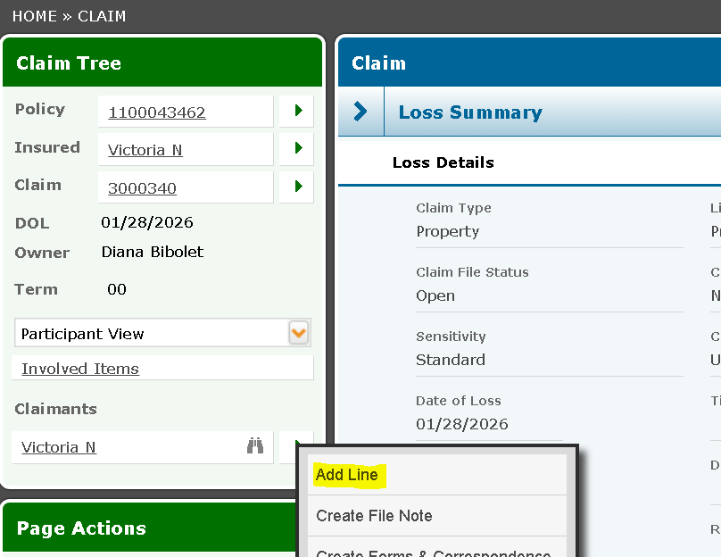
2. Select the line you want to add
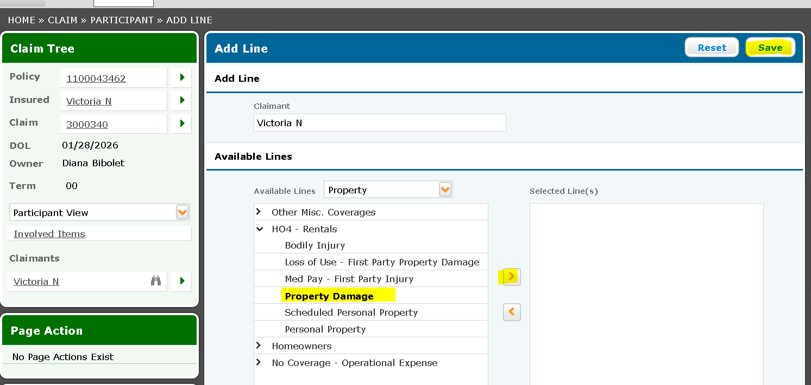
3. Click coverage match
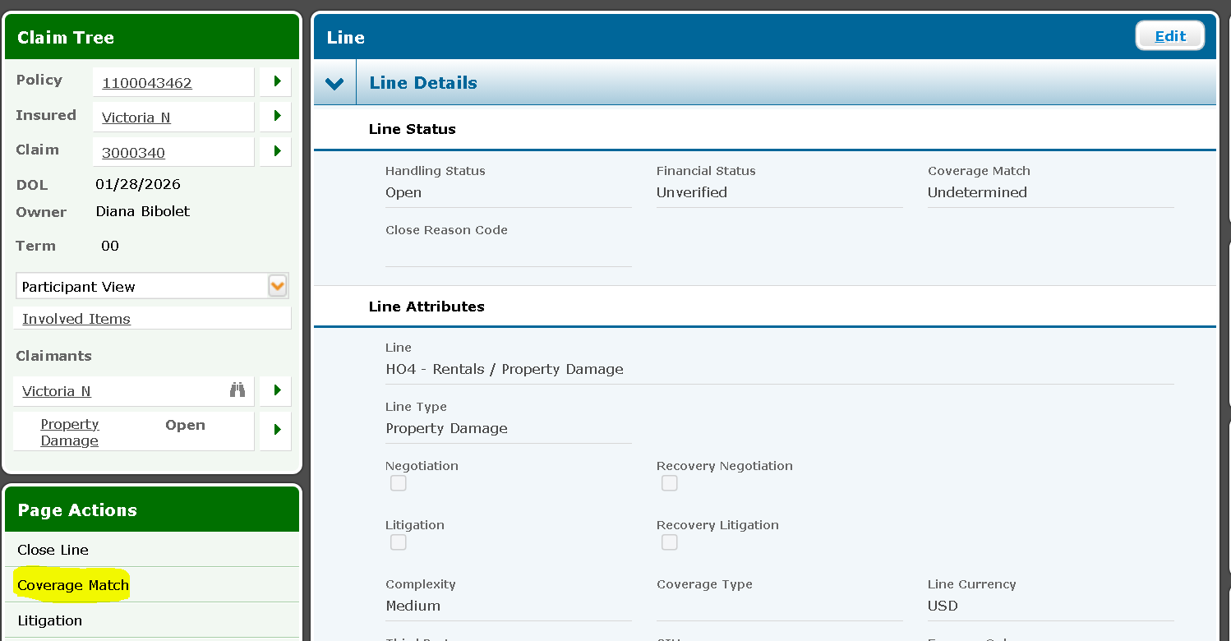
Steps to Post a Payment
- Click on Make Payment to Claimant from the line mega menu
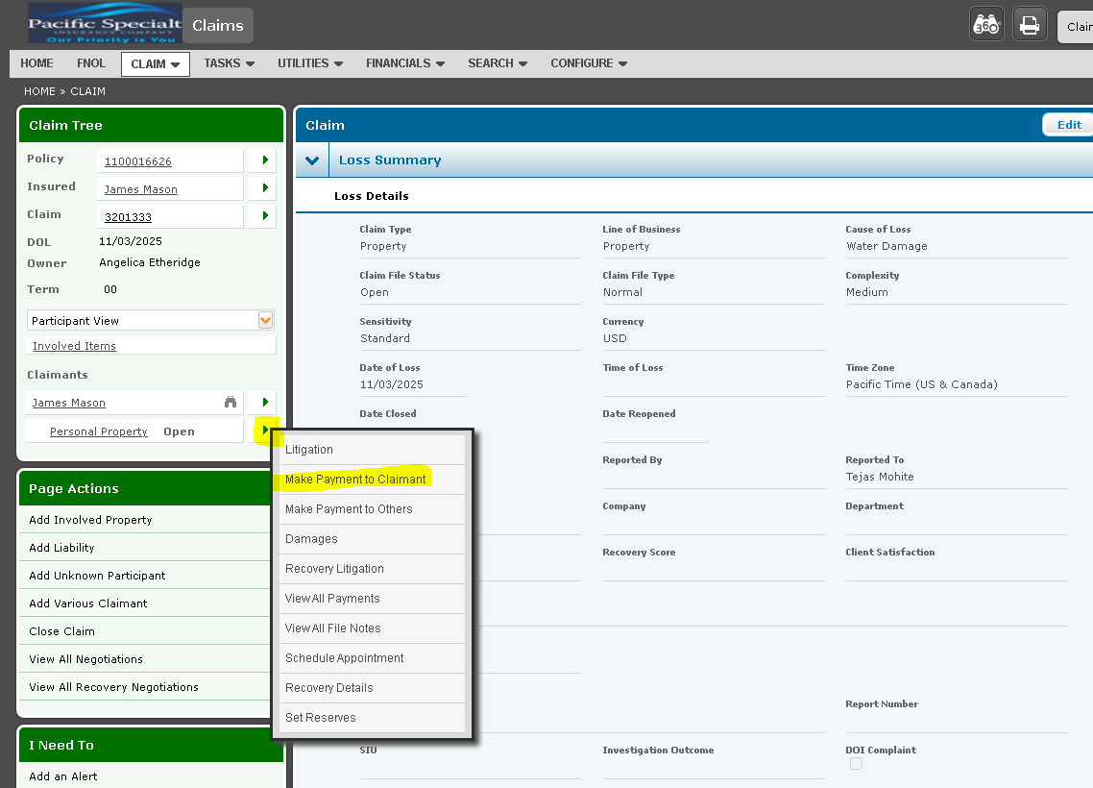

- Fill out the mandatory fields and click save
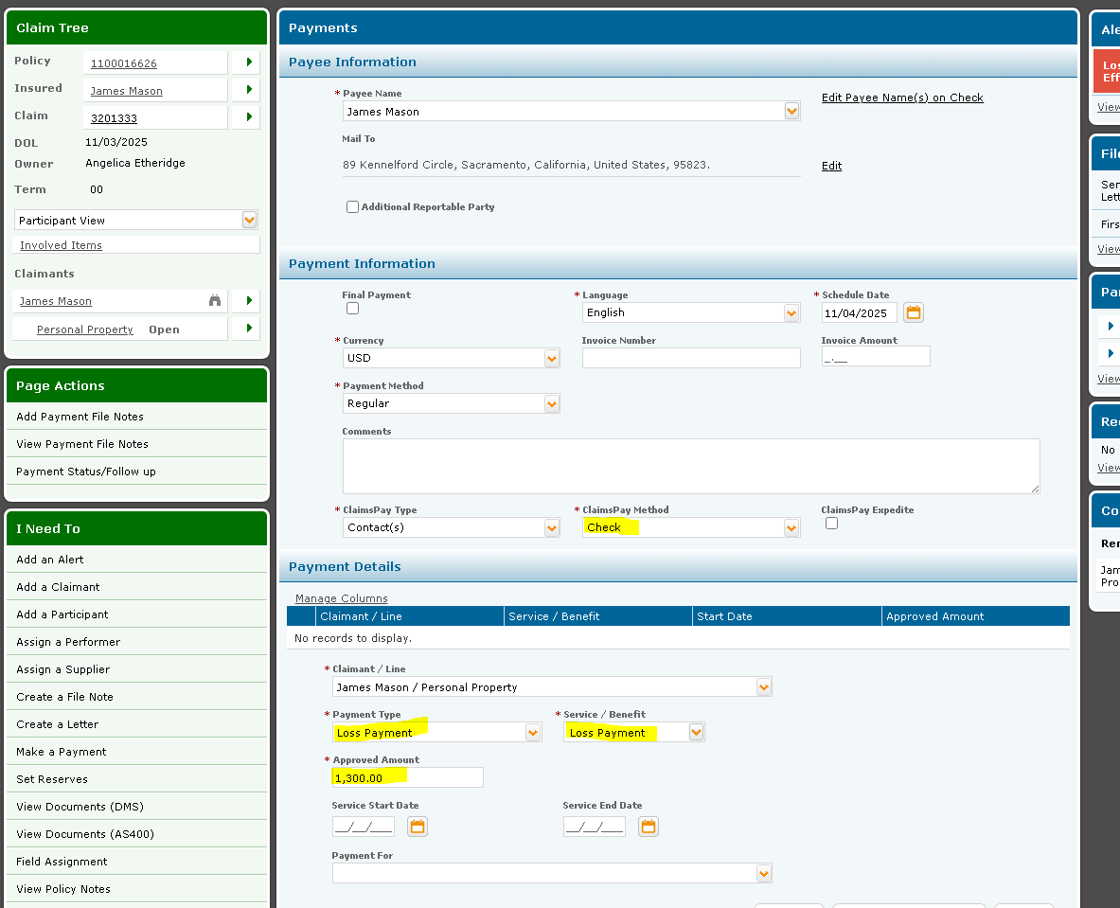

- Once details are saved click on post button
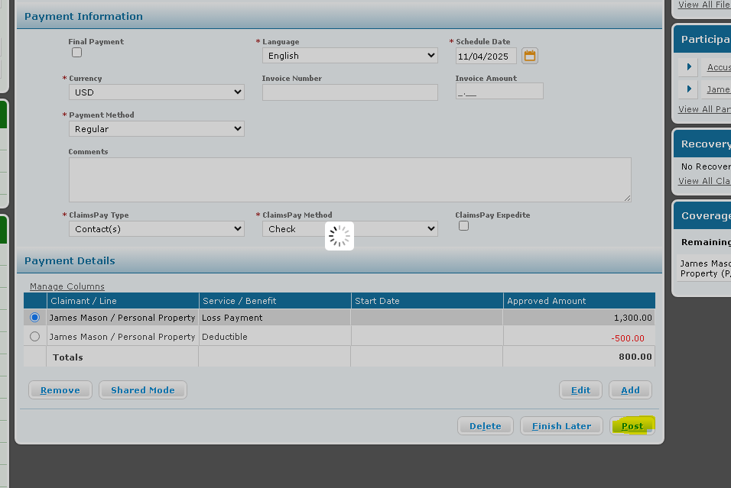

- See the paid amount on the screen
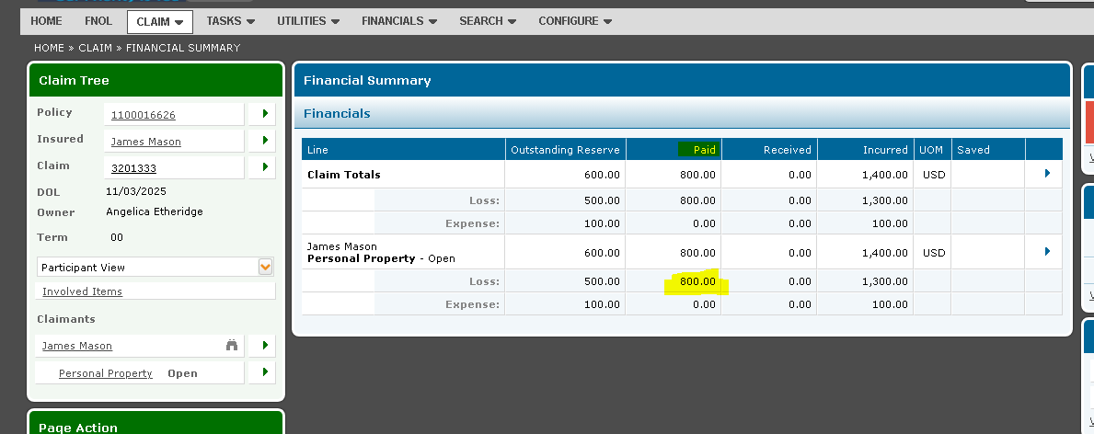

Steps to Close the claim:
1. Go Claim home page, click edit and select ‘Sub Cause of Loss’ and ‘Claims Closure Reason’ and save.
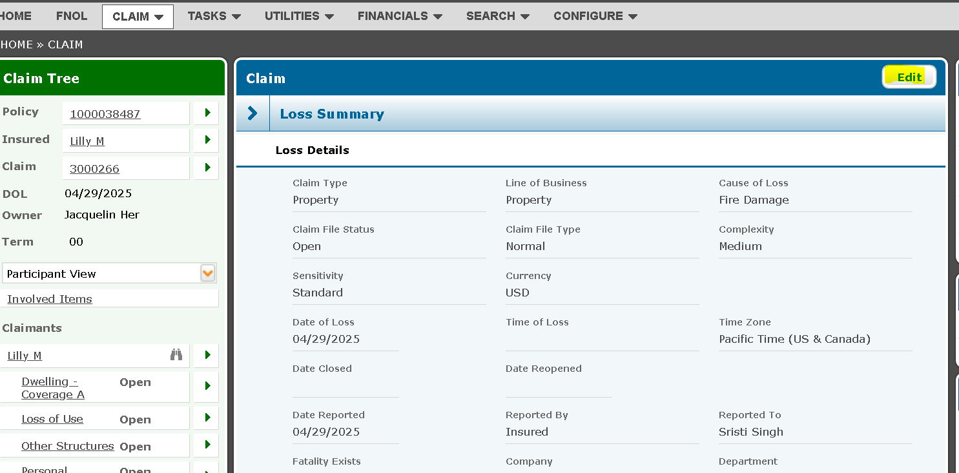
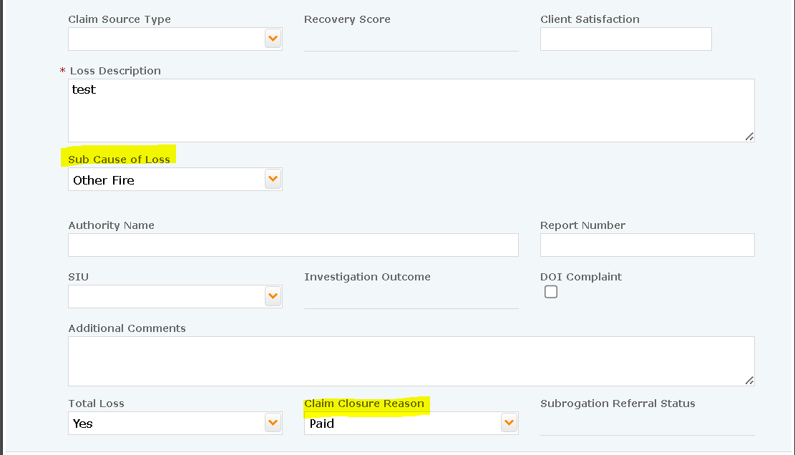

2. from the mega menu, Select ‘All Claim Tasks’
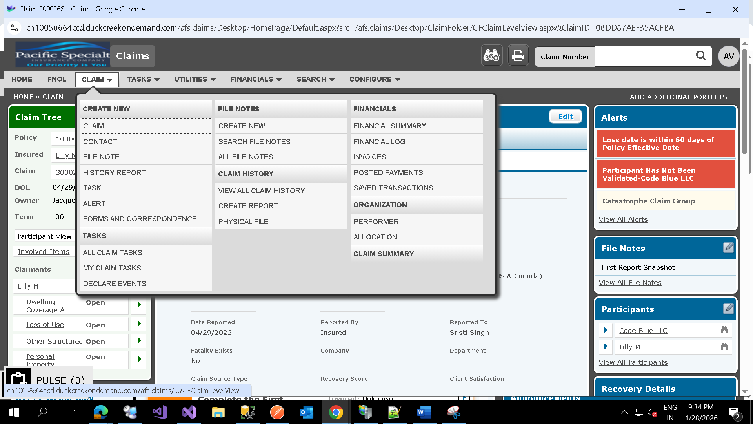

3. from the page actions, select ‘Multiple complete’ and select all the tasks and click complete
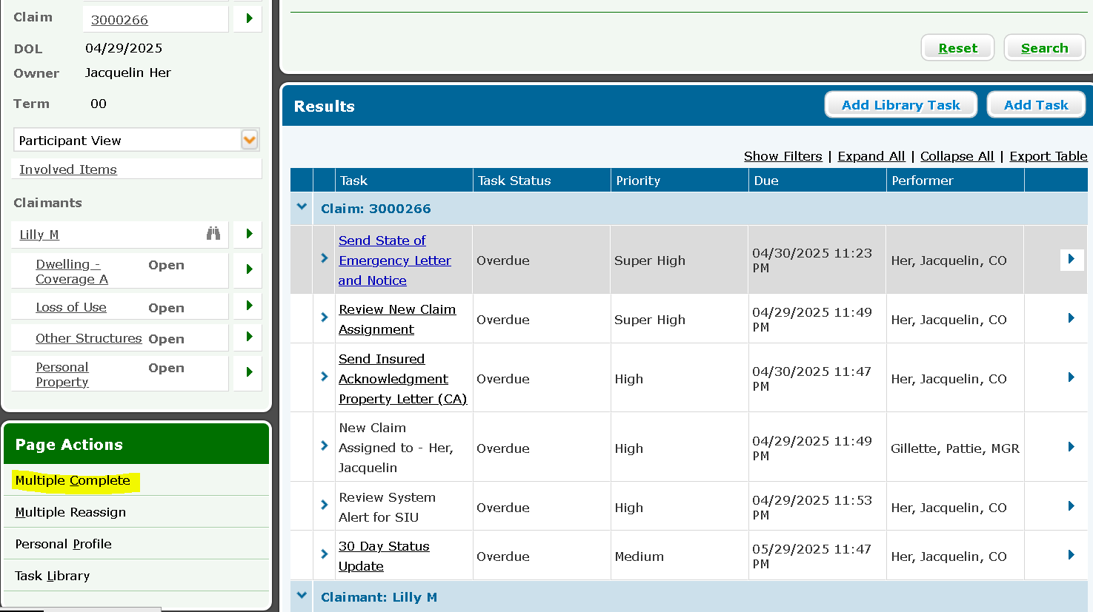
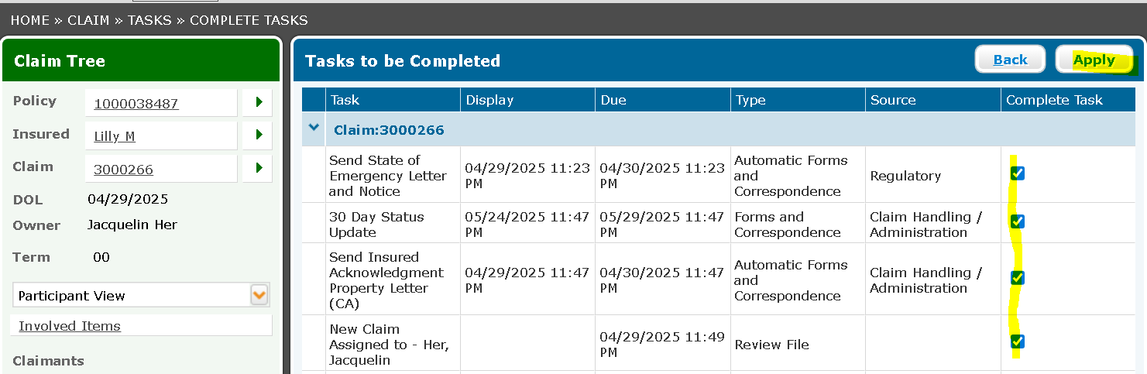

4.Go to claim homepage and click close claim
